Survey for Alaska Drought Discussion

In 2019, parts of Alaska experienced extreme drought. Though wet weather has returned, there is a need to better understand drought and its impacts in all of Alaska to better prepare for future dry conditions. On the heels of a successful workshop in Juneau (see recordings and materials here), focused on drought in Southeast Alaska, we are planning one or two drought workshop(s) focused on mainland Alaska. The goal of the workshop(s) is to have participants get a better sense of drought, impacts of drought and interconnections in Alaska to help refine drought thresholds. Also at the workshop(s) information and resources will be shared to raise awareness about drought and lead to changes in response to dry conditions.

So that this workshop(s) serves Alaska, we would like to hear from you. Please take this survey to help us with meeting logistics and gather some information from you about drought in Alaska. Your time providing us information is appreciated. A summary of survey responses will be sent out to all whom respond with an email address.

There are 19 questions and the majority are only checking a box that applies and five are fill in the blank.

Sincerely,

Alaska Drought Planning Committee: University of Alaska-Fairbanks, Alaska Center for Climate Assessment and Policy, National Integrated Drought Information System, National Weather Service, Western Regional Climate Center, University of Nevada-Reno, Alaska Climate Adaptation Science Center, Inupiat Community of the Arctic Slope, USDA Northwest Climate Hub

Send this completed form to Tina Buxbaum tmbuxbaum@alaska.edu

Please tell us your name, organization and email.
Your answer

With which sector(s) do you primarily work? Check all that apply.

Fisheries

Water supply / quality Energy
Recreation / tourism Wildfire
Forestry and wildlife (other than fisheries or wildfire) Society and public health
Transportation / navigation Agriculture
Weather / climate

Research / university / academia Land managers
Alaskan Native organization Communication
Other:

Recognizing that travel is expensive and resources are limited, would you be able to travel to an in-person meeting in Alaska?

Yes No

Rank potential locations for an in-person meeting (Best, Ok, Not suitable for me, multiple locations can be same category if they are all suitable for an individual):

 | Best | Ok | Not suitable for me

Anchorage

Fairbanks

Other location____________

If, another location is ideal for an in-person meeting other than Anchorage and Fairbanks, note it here.
Your answer

A virtual meeting option will be available (via webinar), which best suits your plans?

- I plan on attending only the in-person meeting.
- I plan on attending only the virtual meeting.
- I plan on attending portions of the in-person and virtual meeting.

Is there a preferred time of year in 2020 to conduct an in-person meeting? (For each month, put an X in box if month is best, ok or not available to you to join an in-person meeting.)

 | Best | Ok | Not available
February
March
April
May
June
July
August
September
October
November
December

Is there an existing meeting we could propose a session or dovetail with?
Your answer

Do you prefer one workshop or two workshops broken out by NWS service area (see image below Anchorage-blue & Fairbanks-red)? NWS-Juneau had a workshop in May 2018.

One workshop Two workshops

National Weather Service areas

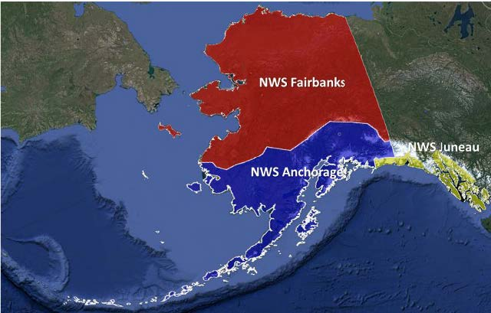

Which is your preference if only one workshop is offered:

One day workshop - Day 1: climate information

Two day workshop - Day 1: climate information, Day 1 & 2: information from a few different sectors & communities, Day 2: information on adaptation strategies (¼-½ day)

Three day workshop - Day 1: climate information, Day 2: information from many different sectors & communities, Day 3 information on adaptation strategies (½-¾ day)

Which is your preference if two workshops are offered, one in each NWS region (Anchorage & Fairbanks regions):

One day workshop - Day 1: climate information

Two day workshop - Day 1: climate information, information from a few different sectors & communities, Day 2: information on adaptation strategies

What is your role with regard to making drought-related management decisions? Please check one.

- I am involved in making and/or implementing decisions related to drought management.
- I provide advice or information to individuals making drought management decisions.
- Both - I provide advice and I make decisions about drought management.
- Neither - I do not make drought management decisions or provide advice. Other:_________

For what types of decisions is drought monitoring information important to you?
Your answer

In your region and/or related to your expertise, which metrics do you think are relevant to drought within Alaska? (Check box of importance for each metric.)

 | Not familiar with | Not Important | Somewhat important | Very important
Precipitation
Standard precipitation index
Snow water equivalent
Snow depth
Soil moisture
Shallow groundwater
Stream flow
Reservoir levels
Temperature
Relative humidity

Which tools and sources of information do you consult with when looking to monitor current drought conditions?
Your answer

What drought impacts have you observed with past droughts and/or dry periods? (put an X next to all you’ve observed)

Low stream flows, fish die-offs Food insecurity
Lower berry production / availability Changes to hunting sites / timing No or limited hydroelectric power Dying trees or vegetation
More wildlife in populated areas they usually avoid Poor air-quality due to smoke
More wildland fires

Less snowpack, less skiing or winter sport activities Changes in recreation
Glaciers melting

Less fungal/mold/algae issues on crops or vegetation
Needing to water plants or crops more than usual

Effects to water quality / drinking water supply / well depth Stress (people)
Transportation issues

Impacts to agriculture / farming / gardening Other_________

Do you have data relevant to drought that you are willing to share?

Yes No

If you do have data that you are willing to share, please describe it.
Your answer

What are the limitations to sharing? (multiple clicks possible)

Not certain who wants it

Data isn’t in an electronic form Proprietary or sensitive information
Too much data to share (large data files)

No limitations already sharing it here (written responses) Other:

