Historical Records
Time Scale: 100-300+ years Spatial Scale: local to landscape level
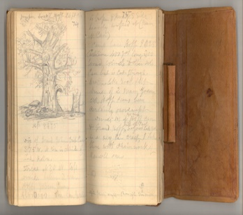
Oral histories, often one person’s perspective, play a crucial role in understanding what the historical fire regime of the oak woodlands looked. Native Californian’s inhabited the oak woodlands for thousands of years and have shared their stories. Other oral histories are from early Euro-American explorer and settlers.
Through these records we have learned that Native Californians burned frequently to decrease fuels and recycle nutrients, control insects and diseases, manage wildlife, foster plants they use for food and textiles, promote shoots to grow straight, and modify the structure of the woodland. Ultimately they maintained habitat for sun loving species that cannot tolerate shade. Some village sites and areas around oak trees where acorns were harvested and burned every year. While areas further away from village sites were burned less frequently, but often enough to maintain woodland resources.
In the early 1800s non-native annual grasses, those that only live for one year, immigrated to California’s oak woodlands from Europe. This impacted fires in the oak woodlands with the change from native bunch grasses to a continuous fuel bed created by the annual grasses. Through the 1800’s fires were frequent and common in the oak woodlands, early settlers used fire as a tool for clearing for agriculture and urban development. Below are just a few examples of historical records of the oak woodlands. While these records can give us an approximation of how and when fires burned, they cannot always tell us the exact fire history for a given site.
●
“They needed to eliminate that duff that was underneath the oak trees because the oaks will drop their leaves and create a big pile of duff (decomposed organic material underneath leaf litter). As long as that duff stayed there, when the acorns dropped, the acorns could only be on the ground just a little while, because the duff was the home of a lot of bugs. The minute they hit the ground; those bugs were into those acorns. So, if they burned it that eliminated the duff and the insects that would get into the acorn.”
Kathy Heffner, as quoted by M.K. Anderson p 146
●
I’m going by what the elders told me happened in the 1800s burning was in the fall of the year when the plants were all dried up when it was going to rain. They’d burn areas when they would see it’s in need. If the brush was too high and too brushy it gets out of control. If the shrubs got two to four feet in height it would be time to burn. They’d burn every two years. Both men and women would set the fires. The flames wouldn’t get very high. It wouldn’t burn the trees, only the shrubs. They burned around the camping grounds where they lived and around where they gathered. They also clear pathways between camps. Burning brush helped to save water. They burned in the valleys and foothills.
Rosalie Bethel, North Fork Mono, as quoted by M.K. Anderson p 152
●
●
California botanist Willis Jepson (1923:39) wrote,
“The long inhabitation of the country by the Indians and the peculiar local distribution of the Valley oak in the rich valleys are in some way connected. These oak orchards, of great food importance to the native tribes, indicate plainly the influence on the trees of Indian occupancy of the country. The extent and nature of the relations of Indian tribal culture and the habitat of the oaks cannot yet, if ever, be completely defined, although it is clear that the singular spacing of the trees is a result of the periodic firing of the country—an aboriginal practice of which there is ample historical evidence.”
The vegetation covering has experienced great changes. Certainly, the chaparral thickets of manzanita, madrone, scrub oak, and buckbrush which now characterize many sections of the Valley were formerly restricted to the higher slopes and ridges of the mountains. A beautiful park landscape, largely of oaks, was maintained by annual burning, done ‘when the straw was dry.’ In this manner the brush was held down and larger trees were uninjured.” (Quoted in Kniffen 1939, retrieved from S. Mensing, 2006)
●
In 1855, Galen Clark visited Yosemite Valley and wrote the following account:
“My first visit to Yosemite was in the summer of 1855. At that time there was no undergrowth of young trees to obstruct clear views in any part of the valley... The Valley then had been exclusively under the care and management of the Indians, probably for many centuries. Their policy of management for their own protection and self-interest…was to annually start fires in the dry season of the year and let them spread over the whole Valley to kill the young trees just sprouted and keep the forest groves open and clear of all underbrush, so as to have no obscure thicket or hiding places or an ambush for any invading hostile foes, and to have clear grounds for hunting and gathering acorns.
When fires did not thoroughly burn over the moist meadows, all the young willows and cottonwoods were pulled by hand. Prepared acorns were as much an article of food with the Indians … In order to get the necessary supply early in the season, before ripe enough to fall, the ends of the branches were pruned off to get the acorns, thus keeping the branches well cut back and not subjected to being broken down by heavy snows in the winter and trees badly disfigured as is the case since that practice has been stopped. Thus, probably for self-protection and utile purposes, the Indians for hundreds of years had cared for and preserved the Yosemite Valley.” (Quoted in Reynolds 1959. Retrieved from S. Mensing, 2006)
●
1854 railroad survey states,
“This timber belt is composed of the most magnificent oaks I have ever seen. They are not crowded as in our forests, but grow scattered about in groups or singly, with open grass-covered glades between them; the trunks often seven feet in diameter, soon divide into branches, which spread over an area of which the diameter is considerably greater than the height of the tree. There is no undergrowth beneath them, and as far as the eye can reach, when standing among them, an unending series of great trunks is seen rising from the lawn-like surface.” (Quoted in Thompson 1961 and Griffin 1988., Retrieved from S. Mensing, 2006)

●

References
M. K. Anderson. (2005). Tending the wild (1st ed.). US: University of California Press. doi:10.1525/j.ctt1ppfn4 Retrieved from https://www.jstor.org/stable/10.1525/j.ctt1ppfn4
Mensing, S. (2006). The history of oak woodlands in California, part II: The Native American and historic period. The California Geographer, 46, 1-31. Retrieved from http://hdl.handle.net/10211.2/2770
Purcell, K. L., & Stephens, S. L. (2005). Changing fire regimes and the avifauna of California oak woodlands. Studies in Avian Biology, 30, 33-45.

Dendrochronology
Time Scale: 50-200 (more for long lived trees) Spatial Scale: direct area

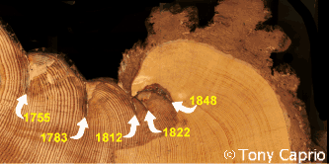
Dendrochronology, or the study of tree’s growth rings, is a common method for understanding the fire history of the area.
Depending on the intensity (or temperature) of a fire, it may cause a scar on the tree. As the tree continues to grow, it will develop chemical and physical boundaries to resist infections. It may even eventually grow new wood that completely covers where the scar has been. Once a tree has a scar, it is easier for it to scar again in future fires.
Scientists look at the fire scars of different trees throughout the forest to build a map of when fires happened and how big they were. Using this method to understand the fire regime of an area only works if the fires where hot enough to scar the trees and if the tree species are susceptible to fire scars. In the oak woodlands, many of the historic fires were not of a high enough intensity, also known as energy output, to scar the oak trees (fires in the oak woodlands are typically low to moderate intensity). Oaks often have rotten portions in their trunks, which cause a loss of these fire records. Another reason this study is difficult in the oak woodlands is because so many of the historic oak woodlands were cut during early Euro-American settlement, leaving few trees for scientists to look deep into the past.
There have been a few studies that used dendrochronology to study the historic fire regimes of the oak woodlands. To complete these studies, scientists first locate trees with fire scars visible on their trunks. Second, they cut a sliver out of the tree with a chain saw, so that the tree can continue to live. Third, they sand this round down so they can clearly see all the growth rings and scars in the tree trunk. Third, then look at the round under a microscope to determine how old the tree is and when fires took place. Fourth, they use computer programs to align growth rings and fire scars in each stand and across a region. One study conducted by McClaren and Bartolome (1989) in blue oak woodland in the central Sierra Foothill showed that fire frequency varied through history. They found that fires happened on average every 25.2 years between 1681 and 1848, 7.1 years from 1849 to 1948, and then there we no fires from 1949 onward.
At the University of California’s Sierra Foothill Research and Extension Center, McClaren (1988) did a similar study, and he found that within the stand with the oldest trees, there were fires in the following years, 1733, 1741, 1773, 1803, 1852, 1856, 1865, 1868, 1871, 1879, 1890, 1900, 1905, 1914, 1919, 1936, 1941, and 1948.
In a blue oak woodland study, a little to the south of these areas, Standiford, Phillips, & McDougald, (2012), found a fire recurrence interval of 12 years, with a range of 5-25 years between fires from 1850-1965. There was no evidence of fire in any of the trees sampled after 1965 (which matches the data from other recorded fire history).
Another dendrochronology study, done on a redwood grove nestled in an oak woodland near Santa Rosa, was conducted by Finney and Martin (1992). They examined the fire scar data from the stumps of historically logged (in the early 1900s) redwoods. They found that the fires happened every 2-10 years within this grove. Because this grove was surround by oak woodlands it is possible that it had a similar fire regime to the oak woodlands surrounding it.
References
Finney, M.A. & Martin, R.M. (1992). Short fire return intervals recorded by redwoods at Annadel State Park, California. Madroño, 39(4), 251-262.
McClaren, M.P., & Bartolome, J.W. (1989). Fire-related recruitment in stagnant Quercus douglasii populations. Canadian Journal of Forest Research, 19, 580-585.
McClaran, M.P. (1988). Comparison of fire history estimates between open-scarred and intact Quercus douglasii. The American Midland Naturalist, 120(2), 432-435. doi:10.2307/2426015
Standiford, R., Phillips, R., & McDougald, N. (2012). Fire history in California's southern Sierra Nevada blue oak woodlands. Fire Ecology, 8(2), 163-167. doi:10.4996/fireecology.0802163

Lake Sediment Core Data
Time Scale: 500-200,000 years Spatial Scale: Watershed
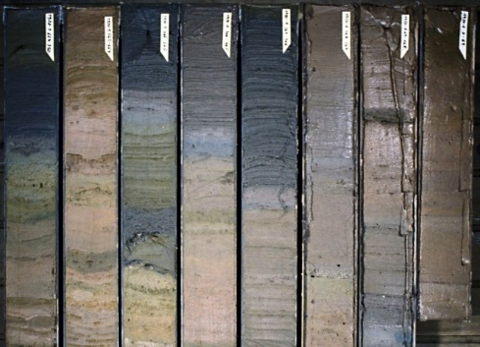
Lake beds accumulate sediments (mud including soil, leaves, wood, pollen and more deposited by settling out of lake water) throughout time and scientists can learn a lot about past climates and fire histories by looking at those sediments.
To collect the sediments, they use a special sediment corer to take a sample from the lake bottom. The sediments at the top of the core are the most recent years, and the sediments at the bottom are the oldest.
Above: Sediment cores from Clear Lake, CA and Mumbo Lake, CA.
Below: Example of sediment pieces.

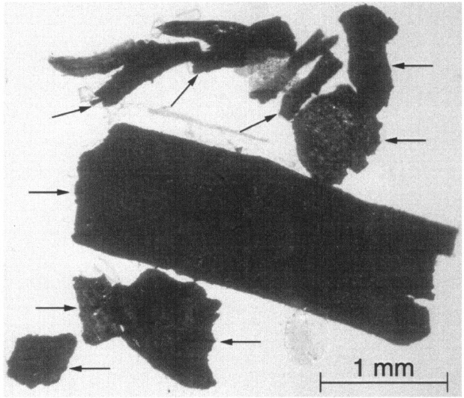
Scientists will look at the pollen in the sediment to determine what the climate was like throughout time. When there is a lot of pollen from plant species that require warmer temperatures or a drier climate, they can conclude that the area around the lake had a climate that met those requirements at that time. Scientists can also look at the amount of charcoal present in a given time to determine if fire occurred in that watershed. The information that scientists get from the cores does not provide enough information for them to say, “We know a fire occurred that was 100 acres in the northwest corner of this watershed on September 25, 1563”. Instead, it gives them information to make estimates such as “Fires happened every couple of years in the watershed during the period of 1500-1650”.
Clear Lake, CA nestled in the oak woodlands of northern California, is the oldest lake in North America. Its sediment cores have provided scientists with an in-depth history of the ecosystems that have surrounded the lake for the past several hundred thousand years. The pollen in the sediment cores paint the stories of ice ages and the rise and fall and rise again of the oak woodlands in the area. Unfortunately, scientists have not done any studies looking at the fire history of the area, but there are studies from nearby lakes that we can make some inferences about what the fire history of the oak woodlands may have been like.
Many lakes across northern California, support the idea of a warmer drier period 5,000-10,000 year ago. During this period there were more frequent fires across the state as could be expected from that type of climate. Following that there was a cooler wetter period, evidenced in Mumbo Lake, in the Trinity Mountains in Northern California. Another warming period occurred more recently, known as the Medieval Climate Anomaly (from 10th-14th century) which is another time when the climate of California was warm and dry and experienced more frequent fires. Following that there is a period known as the Little Ice Age, which meant a cooler wetter climate. While it is expected that fires would decrease during this time, a sediment core study from the Wawona Meadow in Yosemite showed that fire continued with a similar if not higher frequency than before. Scientists think that this frequency increase was from the increase in Native Californians burning at that time. The records from that study show a sharp decline in fire around the early 1900s.
References
Adam, D.P., & Robinson, S.W. (1988). Palynology of two upper quaternary cores from Clear Lake, Lake County, California. Washington: United States Government Print. Office.
Anderson, R.S., & Stillick, R.D. (2013). 800 years of vegetation change, fire and human settlement in the Sierra Nevada of California, USA. The Holocene, 23(6), 823-832. doi:10.1177/0959683612471985
Daniels, M.L., Anderson, S., & Whitlock, C. (2005). Vegetation and fire history since the late Pleistocene from the trinity mountains, northwestern California, USA. The Holocene, 15(7), 1062-1071. doi:10.1191/0959683605hl878ra

Models
Time Scale: day to millennia Spatial Scale: Dependent on model
Scientists can use models to better understand the historical fire regime and to predict future fire behavior in Northern California’s oak woodlands. The US Forest Service’s (USFS) Fire Effects Information System (FEIS) has a collection of fire regime information which provides details of the fire regimes of different ecosystems across the United States. To build the FEIS the USFS uses a combination of data from the scientific literature and from the LANDFIRE succession modeling tool. LANDFIRE uses Biophysical Settings (BpS) which are a representation of the vegetation that may have been dominant on the landscape prior to Euro-American settlement and are based on both the current biophysical environment and an approximation of the historical disturbance regime to build a likely fire regime for that ecosystem.
Below is the LANDFIRE data for the California oak woodlands (Table 1 and 2). The fire interval is how often (on average) fires are likely to happen in this ecosystem. Fire severity is a measure of how many trees are killed in the fire. The data shows what percent of fires in the oak woodlands are likely to fall in each category. The fire regime group that all of the Biophysical Settings models that make up the general California oak woodlands grouping is fire regime group 1 (described in the table below).
Table 1. Modeled fire intervals and severities in California oak woodlands [3]
Fire interval¹ | Fire severity² (% of fires) |  |  | Number of Biophysical Settings (BpSs) in each fire regime group
 | Severe | Mixed | Low | I | II | III | IV | V | NA³
8-16 years | 2-10 | 2-44 | 49-91 | 18 | 0 | 0 | 0 | 0 | 0
¹Average historical fire-return interval derived from LANDFIRE succession modeling (labeled "MFRI" in LANDFIRE).
²Percentage of fires in 3 fire severity classes, derived from LANDFIRE succession modeling. Replacement-severity fires cause >75% kill or top-kill of the upper canopy layer; mixed-severity fires cause 26%-75%; low-severity fires cause <26% [1,2].
³NA (not applicable) refers to BpS models that did not include fire in simulations.

Table 2. Continuation of modeled fire intervals and severities in California oak woodlands
Group | Frequency | Severity | Description
I | 0-35 years | low and/or mixed | Generally low-severity fires replacing less than 25% of the upper canopy layer of vegetation; can include mixed-severity fires that replace up to 75% of the upper canopy layer
II | 0-35 years | replacement | Fires that replace more than 75% of the upper canopy layer (also called high-severity fires)
III | 35-200 years | mixed and/or low | Generally mixed-severity fires; can also include low-severity fires
IV | 35-200 years | replacement | Fires that replace more than 75% of the upper canopy layer (also called high-severity fires)
V | 200+ years | replacement; any severity | Generally, replacement-severity fires, but can include fires of any severity
For more information on this data, you can go to these two links:
https://www.fs.fed.us/database/feis/pdfs/BpS/0311130.pdf
https://www.fs.fed.us/database/feis/fire_regimes/CA_oak_woodlands/all.html
Scientists can also use modeling to predict future fire characterizes like frequency, severity, and behavior. In a study done by Forrestel, et al. (2015) they looked at the impact of Sudden Oak Death (a pathogen that is killing tanoak and costal live oaks in the Coast Range also known as SOD) on predicted fire behavior. To do this they looked at the changes that took place in fuel classes.
Fuel classes, which include 1, 10, 100, and 1000-hour fuels, are a measure of the amount of time it will take for a fuel (meaning dead plant matter) to have the same humidity as the air around it. These classes are important because the amount of moisture in a fuel determines how likely it is to quickly catch during a fire. An example of a 1-hour fuel is a twig smaller than your finger, it will take less than one hour to have the same moisture level as the air around it. An example of a 1000-hour fuel is a downed log, if it rains, it will take 41 days of dry, low humidity weather to completely dry that log out.
Scientists found that areas impacted by SOD had an increase in all fuel types. So, they used BehavePlus, a fire modeling program, to estimate difference in fire behavior for the original fuel amounts and those measured after SOD impacts. The modeling program predicted that a wildfire in the areas impacted by SOD fires would spread faster, have a higher flame length, and produce more heat than in the oak woodlands not impacted by SOD. This information is important for land managers to understand the increased risk of fire in these areas, and for fire fighters to better understand how fires will behave in these ecosystems.
References
Forrestel, A.B., Ramage, B.S., Moody, T., Moritz, M.A., & Stephens, S.L. (2015). Disease, fuels and potential fire behavior: Impacts of sudden oak death in two coastal California forest types. Forest Ecology and Management, 348, 23-30. doi:10.1016/j.foreco.2015.03.024

Observations
Time Scale: 50-100 years Spatial Scale: small area to landscape
Scientists can infer a lot about the history and future of fire in the oak woodlands through observations made real-time during prescribed fires and wildfires. Fry (2008) studied the impacts of a prescribed fire in the spring on the stand structure of a mixed species oak woodland. The fire was of low to moderate intensity and very few of the trees died or were overly harmed. Most of the trees that experienced any scorching in the crown (when the leaves burn) resprouted at the crown and had higher crown coverage the following year. Many of the trees were not damaged to the point of resprouting at the base (something that would only happen if too much of the crown dies). Very few of the trees even obtained fire scars from the fire, with black oak being the most susceptible to scarring. And, four years after the fire, there was no significant difference in stand structure for the oak woodland, which tells us that oaks are very resilient to low to moderate intensity fires.
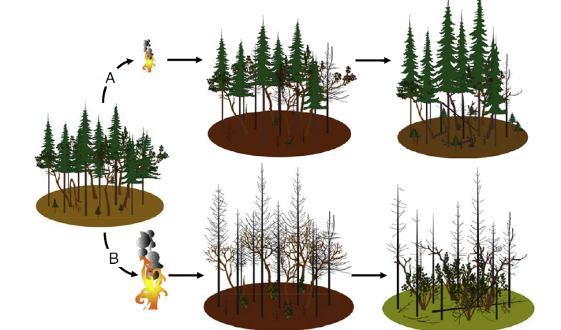
Knowing that oaks can withstand and thrive after fire had some scientists wondering if fire could be used as a tool to restore oak woodlands that are being invaded by conifers. This is a problem caused in part by fire suppression, because normally regular fire will help to burn out small conifers. When conifers start to grow in oak woodlands, they quickly outgrow the oak trees present, making it hard to get the sunlight that the oaks need.
Cocking, Verner, and Sharriff (2012) found that if a fire was of low severity, it will not kill the conifer overstory. The oaks in the understory may resprouts, but are less likely to because they are already weak from lack of resources. Furthermore, there is no sunlight for the oak’s leaves to photosynthesize and they often die. In higher intensity fires that kill conifer overstories, the oaks that resprout are more likely to survive creating an opportunity for the oaks to regain their dominance in the stand.
Hammett, Ritchie, and Berrill’s 2017 study found evidence to support that very thing happening. The area they studied experienced a high intensity fire, and then another fire 12 years later. The majority of oaks that were top killed, 95%, in one or both fires resprouted. In areas where over tory conifers survived, oak sprouts were much smaller. However, in areas where many of the conifers died, the oak sprouts were much larger. These studies give scientists evidence and hope that if a high severity fire is followed by a regular fire regime, many of our oak woodlands may recover from conifer invasion.
Engber and Varner (2012) wondered if the different types of oak leaves had an impact on fire intensity. To study this, they collected leaves from 18 oak species and those closely related to oak species in California. Then, burned them in a lab and measured flame height, flaming duration, smoldering duration, mass loss, and fuel bed depth (this was measured in the field under the trees or shrubs). They found that deciduous oak species (such as the black oak) burned with the most intensity, lost the most mass, and burned the quickest. Many of the scrub oaks and other evergreen bushy oak species with the smallest leaves burned with the least intensity but burned the longest. Evergreen oak trees (such as live oaks) were somewhere in the middle.
These studies along with many others are examples of how scientists use modern-day observations to make inferences about past and future fire behavior in the oak woodlands. Through these observations they can understand how oaks respond to fire, and what that likely means about how fire has shaped and continues to shape this ecosystem.
References
Cocking, M.I., Varner, J.M., & Sherriff, R.L. (2012). California black oak responses to fire severity and native conifer encroachment in the Klamath Mountains. Forest Ecology and Management, 270, 25-34. doi:10.1016/j.foreco.2011.12.039
Fry, D.L.. (2008). Prescribed fire effects on deciduous oak woodland stand structure, northern Diablo Range, California. Rangeland Ecology & Management, 61(3), 294-301. doi:10.2111/07-113.1
Engber, E.A., & Varner, J.M., III. (2012). Patterns of flammability of the California oaks: The role of leaf traits. Canadian Journal of Forest Research, 42(11), 1965-1975. doi:10.1139/x2012-138
Hammett, E., Ritchie, M., & Berrill, J. (2017). Resilience of California black oak experiencing frequent fire: Regeneration following two large wildfires 12 years apart. Fire Ecology, 13(1), 91-103. doi:10.4996/fireecology.1301091

Tree Stands
Time Scale: 100-300 years Spatial Scale: tree stand size
Scientists can tell a lot about a landscape by looking at stands of trees. If all the trees in a stand are around the same age, they know that they started to grow at the same time. Often trees grow after a disturbance that killed the other trees. In the California, the main disturbance is wildfire. And, if a fire is high intensity, it has the potential to kill all the trees present with its high temperatures. Trees grow from seeds or resprouts from the trees whose aboveground stems were killed.
Another clue that can help scientists determine the fire regime of an oak woodland is tree density. Because fire can often kill young oaks and clear brush between trees, if there is an open woodland with lots of spacing between the trees, it is reasonable for scientists to assume that something is happening to prevent the growth of a denser oak woodland. Prior to Euro-American settlement this would have likely been fire, but post settlement an open woodland structure could also be maintained through other management, like grazing.
You can also get a sense of the fire history of the area by looking at the growth patterns of the trees. Many oak species and madrone are adapted to resprout from their base if they are seriously injured during a fire. This creates a growth pattern called fairy rings, where there is a small circle of trees growing together around where the old trunk would have been. When scientists see this growth pattern, they can infer that a fire likely happened in that area previously. These oak sprouts were often managed by Native Californians. They often removed some sprouts fostering trees with a few large stems to promote a formation that was optimal for acorn production and harvesting
Another aspect of tree stands that help scientists to infer the fire history of an area is tree composition. If an oak woodland has a high number of less fire tolerant species such as foothill pine or Douglas fir, scientists can infer that there was likely no fire in an area for some time. When fire is frequent in an oak woodland, it burns the understory and keeps these trees low in numbers. When an area experiences fire suppression, foothill pines and Douglas firs will move-in and quickly overtop many of the oak trees. This is a problem because many oak species need full sunlight to survive. And, when fires do happen, these trees can increase the heat of the fire, making it more likely that the oaks will die.

References
Cocking, M.I., Varner, J.M., & Sherriff, R.L. (2012). California black oak responses to fire severity and native conifer encroachment in the Klamath Mountains. Forest Ecology and Management, 270, 25-34. doi:10.1016/j.foreco.2011.12.039
Fry, D.L. (2008). Prescribed fire effects on deciduous oak woodland stand structure, northern Diablo Range, California. Rangeland Ecology & Management, 61(3), 294-301. doi:10.2111/07-113.1
Hammett, E., Ritchie, M., & Berrill, J. (2017). Resilience of California black oak experiencing frequent fire: Regeneration following two large wildfires 12 years apart. Fire Ecology, 13(1), 91-103. doi:10.4996/fireecology.1301091
Henderson, N.R. & Long, J.L. (1984). A comparison of stand structure and fire history in two black oak woodlands in northwestern Indiana. Botanical Gazette, 145(2), 222-228. oi:10.1086/337450

